1. For the circuit below find the equavalent resistance between the terminals of a and b.

a b

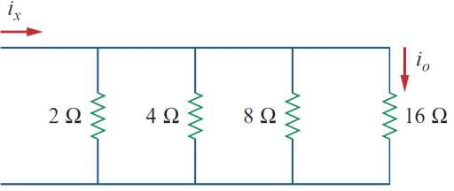

1. İf İx=15 A, calculate io.